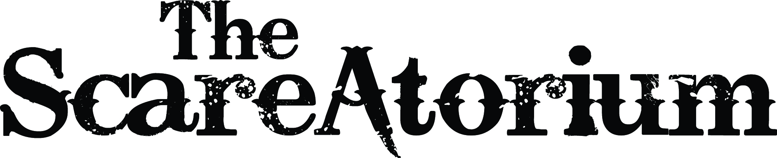

APPLICANT WAIVER FORM

In consideration for the opportunity to work for Funhouse Illusions, LLC d/b/a The ScareAtorium, (“Funhouse Illusions”), I, _____________________________, the undersigned Applicant, (“Applicant”) hereby agree as follows: ^{Please Print} ^{Your} ^{Full Legal Name}

1. Release and Indemnity. To the greatest extent permitted by Ohio law, Applicant hereby waives, releases, and forever discharges Funhouse Illusions and its members, officers, agents, employees, and Funhouse Illusions’ successors and assigns from any liabilities arising from Applicant’s performance under this Agreement. Additionally, Applicant agrees to indemnify and hold harmless, to the fullest extent permitted by law, Funhouse Illusions and its officers, agents and employees from and against all claims, damages, losses and expenses, including but not limited to attorney's fees and expenses, arising: (i) the action or inaction of Independent Applicant; (ii) any breach of the representations or warranties contained here; or (iii) any loss, liability, damage or cost Funhouse Illusions may incur due to the presence of Applicant in or on the premises located at 2605 Northland Plaza Drive, Columbus, Ohio 43231.
2. Independent Contractor. Applicant understands and agrees that Applicant’s relationship to Funhouse Illusions is that of an independent contractor and that Applicant is not an employee of Funhouse Illusions. Except as otherwise required by applicable law, Applicant shall not receive or participate in any Funhouse Illusions health insurance, fringe benefits or other employee benefit plans. Funhouse Illusions will have no responsibility to withhold or pay any income or other taxes on Applicant’s compensation or to provide any insurance, retirement or other employee benefits to Applicant.
3. Termination. The Applicant understands and acknowledges that Funhouse Illusions or Applicant may terminate this Agreement at any time, with or without cause.
4. Release of Likeness. Applicant grants irrevocable permission to Funhouse Illusions, its members, officers, affiliates, successors, and assigns, to photograph, film, videotape, record, or otherwise capture Applicant’s likeness. Applicant authorizes Funhouse Illusions to use of his or her likeness for any purpose, including, but not limited to promotional purposes. Applicant understands and agrees that he or she will not receive compensation of any kind in connection with any use of Applicant’s likenesses by Funhouse Illusions. Applicant understands and agrees that he or she retains no rights regarding the ownership, use, or control of his or her likeness by Funhouse Illusions.

5. Non-compete and Confidentiality. For one (1) calendar year after this Agreement has been executed by both parties, Applicant shall not directly or indirectly engage in any activity for the purpose of preparing to compete with Funhouse Illusions’ business or otherwise engage in any activity, directly or indirectly, competitive with Funhouse Illusions’ business, whether alone or as an officer, director, shareholder, partner, member, lender, employee, agent, trustee, fiduciary or other representative of any other individual, company, corporation, partnership, trust or other entity. During the Contract Period and after this Agreement terminates, Applicant shall not disclose or use, for her benefit or the benefit of any third party, any information of any kind which Funhouse Illusions considers confidential. Upon termination of this agreement, Applicant shall return all Funhouse Illusions information of any kind and all copies thereof in any and all forms in which it may be maintained. During the term of this Agreement, upon termination or at any subsequent time, Applicant shall maintain the confidentiality of all business, financial, customer and other material information relating to Funhouse Illusions and its operations. This provision shall survive termination of this Agreement.
6. Medical Consent. Applicant authorizes Funhouse Illusions, its members, officers, employees, agents, and volunteers to take whatever steps may be necessary to obtain emergency medical care for the Applicant.

7. Severability. The provisions of this Agreement are severable. If any provision is deemed invalid or unenforceable by a court of competent jurisdiction, it shall not affect the applicability or validity of any other provision of this Agreement, but rather such provision shall be amended by the court to the extent necessary to render it valid and enforceable.

If Applicant is over 18, please sign and date immediately below.

ADULT APPLICANT:

Signature:
Date:
Social Security Number: ________________________

Email: ____________________________________

Phone: ___________________

If Applicant is under 18, a parent or guardian must sign, date, and provide the Applicant’s date of birth.

MINOR APPLICANT:

Parent/Guardian Signature:
Date:
Applicant’s Date of Birth:
Social Security Number: ________________________
If Applicant is over 16, we must have a social security number.

